CSC 235, Introduction to Linux &

Linux Administration

Fall 2023

**Individual Course Project: Ansible and Vagrant**

**Due: Friday, October 20, 2023 (NLT 23:59)**

**Instructions:**

1. Insert your answers into this document (*text and screenshots*)
2. Highlight your answers in green (*text only*)
3. When finished, rename the document (*please use the naming convention below*)
4. Upload the renamed document to the Moodle assignment

**Project - last name, first name.docx** (e.g., **Project - Nonnweiler, Joel**)

**Project Requirements**

Links have been provided in Moodle – Week 6 for the resources you require.

1. **Install Ansible**
   * Provide a screenshot showing the version after installing it. This includes”
     + Ansible version
     + python version
     + jinja version
     + libyaml = True

Here is the output of what I want you to include in your report. I hid the command – this is something you need to find for yourself

1. **Run your first ad hoc ansible command**
   * Provide a screenshot demonstrating it ran

You should see: <ww.example.com> | success >>

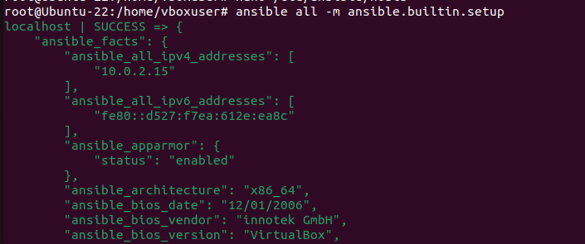

**Part II: Install Vagrant**

Vagrant is a tool to manage virtual machine environments, and allows you to configure and use reproductible work environments on top of various virtualization and cloud platforms.

1. **Download and install Vagrant Serve either in Windows or in Virtual Box Ubuntu**

You will need to add a ‘vagrant box – there are many open-source pre-made vagrant boxes you can download and install; the vagrant website has a link to the boxes. I added ubuntu/xenial64. The Vagrant site has a link to boxes.

Demonstrate you added it by taking a screenshot of the confirmation – see below:

Note: there are specific basic vagrant commands you need to familiarize yourself with. [Click here](https://www.vagrantup.com/docs/cli) for the common CLI commands’ Here are three useful ones. vagrant add, remove, halt, destroy, ssh

1. **Boot your Linux server with vagrant up command**

You should see a new Linux session start as the image displays below

**Part III: Configure Ansible with Vagrant & Create and run a network Ansible playbook**

1. Test Ansible with Vagrant
2. Create and run your first network Ansible playbook 10.0.2.255
3. A screenshot of a computer program

   Description automatically generated
4. Write a simple hello-world message. You will need to create a .yml file and executed in Ansible.
5. A screenshot of a computer screen

   Description automatically generated
6. Automate a repeatable task such as updating the Linux distributions.

**Part IV Report**

Your report is in a form of documenting what you have done. It should include the following:

1. Introduction to the project
2. Step-step-by-step what you did to accomplish the specific requirements. Add screenshots.

If you came across stumbling point, reference it, and add it to the Appendix with notes how you overcame it.

1. Conclusion: Include what you have achieved and learned. This should also include next steps: (a) you achieved all the requirements, and what you could do next to build on what you have learned; or (b) what you would do next to meet the requirements if you have not achieved them.
2. References: Please list web addresses, pdf files, or any other resource you have used to help you meet the requirements of the project.
3. Appendix I – this is your reference troubleshooting guide. State issue, and how it was resolved. You can include a glossary of terms. Think of it as a ‘training’ document.
4. Appendix II: Include code – please include your .yml files.

**Deliverables uploaded to Moodle:**

1. Report
2. .YML files

[https://medium.com/@AnnaJS15/getting-started-with-virtualbox-and-vagrant-8d98aa271d2a](https://medium.com/%40AnnaJS15/getting-started-with-virtualbox-and-vagrant-8d98aa271d2a) <https://www.taniarascia.com/what-are-vagrant-and-virtualbox-and-how-do-i-use-them/>